**KMEAN’s OUTPUT:**

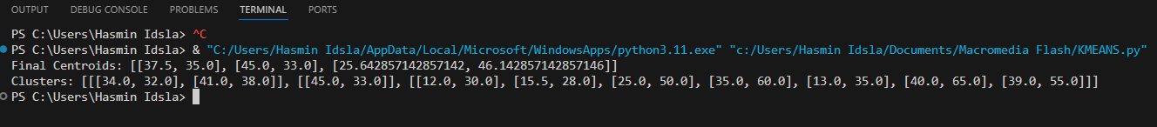

**KNN OUTPUT:**

